|  |
| --- |
| Aquantis Inc. |
| 250kW Scaled Hydrostatic Drivetrain Test Plan |
| Aquantis 1.5MW C-Plane Development |

|  |
| --- |
| Tyler Mayer, Aquantis Inc.  Revision: Draft 02  4-2-2014 |

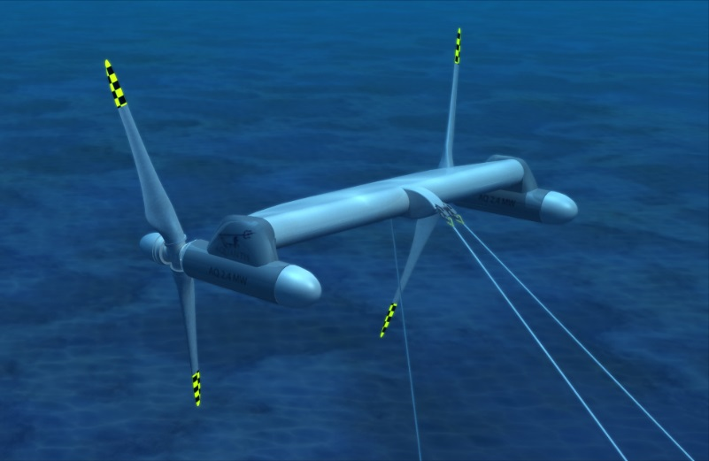

# Aquantis/Bosch-Rexroth Drivetrain Test Plan

## Executive Summary

This document defines the technical requirements for the 250kW scaled drivetrain test of a hydrostatic transmission for use in a Marine Hydro Kinetic (MHK) energy device.

|  |  |  |  |  |  |  |  |  |  |  |  |  |  |  |  |  |  |  |
| --- | --- | --- | --- | --- | --- | --- | --- | --- | --- | --- | --- | --- | --- | --- | --- | --- | --- | --- |
| |  |  |  | | --- | --- | --- | | Change History | | | | **Revision** | **Description of Change** | **Date** | | Draft 01 | Release for Internal Review | 07/22/2013 | | Draft 02 | Update Test Parameters, add Overspeed Power Regulation, Lubricant Efficiency and Pump Switching Cases. | 04/02/2014 | |  |  |  | |  |  |  | |

THIS DOCUMENT, OR AN EMBODIMENT OF IT IN ANY MEDIA, DISCLOSES INFORMATION WHICH IS PROPRIETARY, IS THE PROPERTY OF AQUANTIS, INC. & ITS SUBSIDIARIES, IS AN UNPUBLISHED WORK PROTECTED UNDER APPLICABLE COPYRIGHT LAWS, AND IS DELIVERED ON THE EXPRESS CONDITION THAT IT IS NOT TO BE USED, DISCLOSED (INCLUDING REPRODUCTION AS A DERIVATIVE WORK), OR USED FOR MANUFACTURE FOR ANYONE OTHER THAN AQUANTIS INC. & IT’S SUBSIDIARIES WITHOUT ITS WRITTEN CONSENT, AND THAT NO RIGHT IS GRANTED TO DISCLOSE OR SO USE ANY INFORMATION CONTAINED THEREIN. ALL RIGHTS RESERVED. ANY ACT IN VIOLATION OF PRIOR AGREEMENT OR APPLICABLE LAW MAY RESULT IN CIVIL AND CRIMINAL PENALTIES.

Aquantis 250kW Scaled Drivetrain Test Plan DRAFT v02.docx

Date of Submission: 04/02/2014

Contents

Aquantis/Bosch-Rexroth Drivetrain Test Plan 1

Executive Summary 1

Change History 1

Background 3

Scope 3

Test Objectives 3

System Design Validation 4

Facility 4

Test Bench 4

Schedule 5

Test Configuration 6

Technical Approach 7

250kW Design and Analysis 7

Nominal Test Conditions (Steady-State Operation) 7

Transient Operating Conditions 8

Stall Control Validation 9

High Ratio Dynamics Validation 9

Low-Voltage Ride-Through (LVRT) Simulation 10

Lubricant Efficiency 10

Pump Switching Efficiency 10

Sensors List 10

Deliverables 11

## Background

Aquantis, Inc. proposes to conduct a test of a marine hydrokinetic (MHK) system hydrostatic drivetrain in a test bench environment. This test seeks to gain operating information about the integration of commercial hydraulic components into a low speed, high torque hydrostatic drivetrain. The drivetrain test will evaluate the dynamics of the system, the controls to operate the system, overall system efficiencies and the ability to operate in compliance with the electrical grid. This test is proposed to be in partnership with Bosch-Rexroth, Aachen University and the Institute for Fluid Power Drives and Controls. The test will further validate the hydrostatic transmission as a highly torque dense alternative to direct drive or gearbox based MHK drivetrain systems, allowing for variable speed operation without converter power electronics and thus reducing part count and cost of energy.

## Scope

The objective of the test program is to characterize the performance of the main components of the proposed hydrostatic transmission system to be used in the Aquantis Marine Hydro-Kinetic (MHK) device for commercial power generation. To verify the feasibility and the expected properties of such a drive train, a scaled version of approximately 250kW shall be designed, simulated and tested in a laboratory environment. The scaled drivetrain will utilize a Hagglunds pump and Rexroth generator drive motors of similar design and representative operation of the full scale system.

The drivetrain will be evaluated under a comprehensive test program including performance at steady-state, transient and fault conditions. In addition the test will evaluate the impact of stall regulation and high ratio dynamics. These test cases will allow comprehensive evaluation and measurement of the dynamics of the system, the controls to operate the system and the overall system efficiencies.

## Test Objectives

1. Validate behavior during all modes of operation and response to failure events.
2. Reduce technical risk in key areas of design.
3. Validate system design (control valve manifold, accumulators, cooling system, etc.)
4. Steady-state performance at cut-in, rated and cut-out operating points.
5. Transient behavior for start, stop, ramp up/down and various fault conditions
6. Efficiency over the proposed operation range
7. Control system performance - maintain synchronous speed throughout the operating range
8. System control during curtailment
9. Hydraulic braking scheme
10. Validate system analysis models

## System Design Validation

A secondary set of objectives for the tests are to assess the various features of the proposed Aquantis system design, such as:

1. Control valve manifold design and configuration including pressure relief, bypass and braking valves. These valve manifolds are critical to the operation and control of the Aquantis system and for validating the various operational scenarios
2. Determine the requirements for accumulators on the high- and low-pressure sides of the transmission circuit to manage system transients
3. Anticipated cooling system requirements
4. Provide data for an analysis of system reliability

## Facility

The Institute for Fluid Power Drives and Controls (IFAS) at the RWTH Aachen University has played a major role in the development of a hydrostatic drive train to be applied in wind turbines. IFAS has also a 1MW HDT-test bench for developed for wind power applications installed in their laboratory.

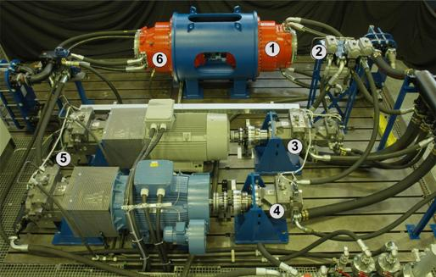

Figure – Existing IFAS test stand proposed for testing

### Test Bench

The 250 kW test bench will utilize the existing test bench componentry including the pump configuration of coupled Hagglunds CBP840 and CA210 pumps. This architecture has a combined torque capacity of 1050 Nm/bar, combined displacement of 66 l/rev and will be operated from 3-15 RPM at pressure up to 250 bar.

The following components will be installed on the existing test bench to meet the required test configuration.

* Hydraulic piping from pump to motors: Low pressure line will be connected to the wind power transmission supplying the system with pre-charged low pressure, oil, cooling and filtration.
* Valve block(s) and manifolds
* Hydraulic motor(s)
* Asynchronous generator driven by the hydraulic motor(s) including a torque measuring flange and soft starter to be connected to the grid.
* Controller for drive and hydrostatic transmission.

Because the test installation of the HDT is sharing parts of the existing IFAS infrastructure, especially parts of the existing HDT for Wind Energy, the hydraulic fluid to be used is determined by fluid choice for the Wind Energy HDT.

## Schedule

The preliminary schedule of the test program is show in the figure below.

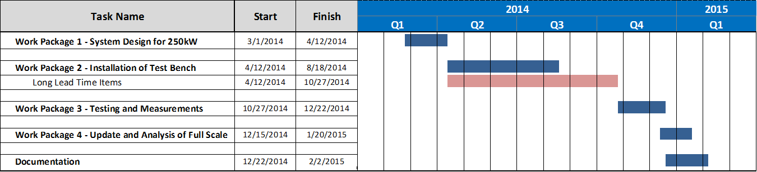

**Project duration and deadlines:**

Project start: Week 34 / 2013

Project duration: 44 weeks

## Test Configuration(Preliminary, to be determined)



## Technical Approach

### 250kW Design and Analysis

The drivetrain test will utilize a 250 kW system scaled using the current full scale 750kW drive-train design. Each component of the system will be scaled while leaving the system layout as close to the full scale design as possible. This will allow the measurement and analysis results to be directly representative of the full scale drivetrain.

A simulation model of the entire 250 kW system will be used to analyze the behavior of the drivetrain under the conditions described in the test plan. This analysis model will allow assessment of:

1. Steady state performance including efficiency at proposed operation range
2. Transient conditions (start, stop, emergency stop, fault conditions)
3. Dynamic behavior of the drive train applying load from a specific site
4. Analyze different system configurations static and dynamic
5. Control system to keep synchronous speed

The findings of the simulations will be used to update and improve the system. In addition the analysis results will serve as a baseline for comparison of the test measurements and validation of the analysis tools.

### Nominal Test Conditions (Steady-State Operation)

The steady-state operating performance of the system shall be measured over the entire operational range of the C-Plane. The steady-state operating performance of the hydraulic circuit shall be measured at various points within the normal range of the marine current resource through simulated flow speeds of 0.9 to 1.8 m/sec.

The steady state test cases will be run at torque levels of 25%, 50%, 75% and 100%. Each run is estimated to be 15 minutes in duration.

Table 1: Nominal Test Conditions



### Transient Operating Conditions

The following transient conditions shall be tested: start-up sequence, shut-down sequence, ramp up, ramp down, power curtailment and emergency stop. The purpose of this series of tests is to determine the effectiveness of the motor displacement/speed control to react to a series of transient events that are to be expected operationally. In addition, the result of these tests will allow assessment of potential pressure spikes and mechanical shock as well as development of strategies to manage undesirable effects. Finally these transient tests will give an assessment of the dynamic response and stability of the system to perturbations.

The following transient conditions shall be tested in order to develop the control schemes necessary to assess the suitability of the system to grid connection:

* Start-Up / Shut-Down Sequence
* Ramp-Up / Ramp-Down of Speed
* Power Curtailment
* Other applicable fault conditions as outlined in IEC 61400-21

Preliminary startup/shutdown and operational control schemes have been developed for Aquantis and more detail can be provided as needed.

#### Start Up Sequence/ Shut-Down Sequence

An induction generator will be used for the prototype systems, this generator requires "motoring-up" to match grid voltage and frequency. The start-up sequence anticipated for the full scale system will be duplicated in the test environment. Based upon the test, estimated system operating parameters will be determined including: required motor displacement and system pressure based on loaded rotor speed and resource velocity. The shut-down sequence will be approximately the reverse of the steps described above.

The startup and shut down shall be simulated for the following cases:



#### Ramp up and Ramp down

The hydrostatic drivetrain will be subjected to ramp up and ramp down rates to assess the control system ability to react and maintain constant power output under changing flow speeds.



#### Power Curtailment

The objective of the active power set point or power curtailment simulation is to demonstrate the extent of compliance that can be expected when the system is commanded to operate at reduced power. In this test the electric power from the generator is reduced. The motor displacement is increased (to max) dropping the pressure and allowing the rotor (pump) to accelerate. The system finds a new equilibrium point, off-optimum Cp (efficiency), and reduced power.

Power curtailment cases are to be simulated at 25%, 50%, and 75% nominal power. The full test parameters of each case is to be developed.

#### Fault Conditions

The following fault conditions are to be simulated. The test parameters of each case are to be developed.

* Emergency Stop
* Extreme Overspeed
* Loss Input Torque

### Overspeed Power Limit Control Validation

In certain events it may be advantageous to run the rotor in an overspeed condition yet maintain constant power output. In the proposed overspeed operation, the control system will increase the displacement in the motors decreasing the transmission ratio and the effective torque of the generator. The rotor will speed up reducing its performance and efficiency. The rotor will operate at a reduced Cp and increased TSR while maintaining constant generator power output. This test will evaluate the system’s ability to maintain constant generator output at decreased rotor torque levels.

The test cases will begin at the nominal test conditions of test case (s-12) and ramp to the conditions shown in the table below. The test cases may be run in succession remaining at each step for a minimum of 5 min. Each run is estimated to be 15 minutes in duration.



### Stall Control Validation

In certain marine current resources stall control may provide an effective means to manage flow excursions. In the proposed stall control operation, the control system will decrease the displacement in the motors increasing the transmission ratio and the effective torque of the generator. The torque increase drives the rotor to a slower speed thus reducing its efficiency. The rotor will operate at a reduced Cp and reduced TSR while maintaining constant generator power output. This test will evaluate the system’s ability to maintain constant generator output at increased rotor torque levels.

These test cases will be run at reduced torque levels so as to not damage the facility. The test cases will begin at the nominal test conditions of test case (s-10) and ramp to the conditions shown in the table below. The test cases may be run in succession remaining at each step for a minimum of 5 min. Each run is estimated to be 15 minutes in duration.



### High Ratio Dynamics Validation

In the process of scaling the drivetrain to 250 kW the nominal input RPM increased from 5.5 RPM to 12.4 RPM. The following test will reduce the input speeds to simulate the very high transmission ratios of the full scale design. For this test the fixed displacement motor will be removed/ disconnected from the system. Each test case is estimated to be 15 minutes in duration.



### Low-Voltage Ride-Through (LVRT) Simulation

Additional desired test scenario of Low-Voltage Ride-Through (LVRT) of the hydrostatic drivetrain are not included in this test due to budgetary considerations.

The LVRT simulation consists of the instantaneous removal and re-application of the generator load that may result from various electrical grid faults. The events are generally short duration (≤500 ms) and the magnitude of the load disturbance can be as high as 80% (full load to 20% of full load back to full load).

### Lubricant Efficiency

An additional test scenario of investigating drivetrain performance and efficiency at various lubricant viscosities. Fluid viscosity will be adjusted using temperature. Temperature modulation will be achieved through varying flow rates through the cooling system. The nominal steady state test cases from table 1 will be re-run at the 100% torque level for 3 temperatures to be determined. Each run is estimated to be 15 minutes in duration.

|  |  |
| --- | --- |
| Temperature | Viscosity at Temperature |
| 30° C | XX Cst |
| 40° C | XX Cst |
| 50° C | XX Cst |
| 60° C | XX Cst |

### Pump Switching Efficiency

Additional test cases will investigate the drivetrain efficiency using pump switching of the low speed pumps to discreetly change fluid volume. Test cases and switching strategy to be determined.

### Pump Switching Efficiency

Additional test cases will investigate the drivetrain efficiency using pump switching of the low speed pumps to discreetly change fluid volume. Test cases and switching strategy to be determined.

## Sensors List

System data to include, but not be limited to: Flow and pressure, rotational speeds of components, torques (where measured), electrical power output, control valve input signals, sensor outputs, fluid specification, etc. The full detailed list of sensors and channel is to be developed.

|  |  |  |
| --- | --- | --- |
| Sensor | Location | Purpose |
| Input Speed |  |  |
| Output Speed |  |  |
| Input Torque |  |  |
| Output Torque |  |  |
| System Pressure |  |  |
| System Flow |  |  |
| Power Output |  |  |
| Valve Signals |  |  |
| Motor Displacement |  |  |
|  |  |  |

## Deliverables

The test plan described in this document will validate the integration of commercial hydraulic components into a low speed, high torque hydrostatic drivetrain. The proposed drivetrain tests gather valuable operating information on the dynamics of the system, the controls to operate the system, overall system efficiencies and the ability to operate in compliance with the electrical grid.

The deliverables of the test are as follows:

1. Detailed list of components used in the test with full specifications
2. System schematic diagrams for hydraulics and controls system
3. Steady-state performance data over prescribed operating range*
4. Transient performance data over prescribed operating range*
5. Start-up and shut-down sequence of operations documentation
6. Component life assessments
7. Detailed test report

* Note: System data to include, but not be limited to: Flow and pressure, rotational speeds of components, torques (where measured), electrical power output, control valve input signals, sensor outputs, fluid specification, etc.